Year 2 Newsletter
Welcome to Year 2, I hope you have all had a restful summer and feel energised and ready for the experiences that Year 2 has to offer. We have so many wonderful things planned for you this term.
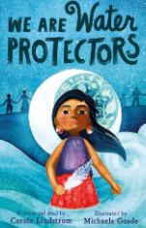
English
We start of with the book called we are Water Protectors by Carole Linstorm. Your child will explore the true story of a narrative and produce descriptive non-fiction writing in different forms such as writing the life- cycle of water and identifying environmental issues. They will also be researching the Native American tribes and creating a campaign to look after local water.
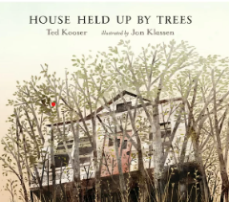
We will then explore House held up by trees by Ted Koser where will be exploring the hidden meaning of the text, including what the deeper message of the book could be. They will write a report and advertisements.
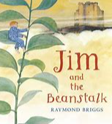
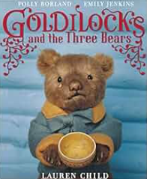
In Autumn 2 we move on to navigate our way through the books The Goldilocks Project. We dive into 3 different books where we will explore sequel stories and retellings from another point of view. We will read into Jim and the Beanstalk where we will write narratives, dialogue and thought bubbles.
Reading
In year 2 we continue to develop your child’s independence when changing their reading books. When you child has read their books at home they can change them themselves from the banded books. We will support your child to do this but in a morning at drop off. If your child has read get their reading packets out ready for them to change when they enter the class. Don’t forget to sign the books when read,
We also have three sessions a week of whole class reading and listen to your child read. You must continue to read with your child at least 3-4 times a week to develop fluency and retrieval skills.
Reading Challenge
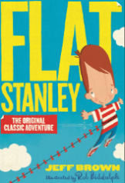
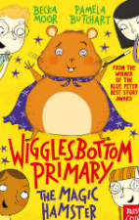
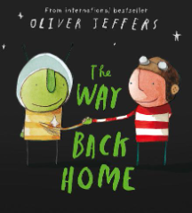
The Reading challenge books are The way back home by Oliver Jeffers Wigglebottom Primary The Magic Hamster by- Becka Moor and Flat Stanley by Jeff Brown. All books need to be read by July 2025 to claim your certificate. The challenge is on!

Maths
In Maths we will be focusing on reading and writing numbers to at least 100 in numerals and in words. We will be recognising the place value of each digit in a two-digit number (tens, ones). We will Identify, represent and estimate numbers using different representations, including the number line. Show that addition of two numbers can be done in any order (commutative) and subtraction of one number from another cannot. Add and subtract, multiply and divide numbers using concrete objects, pictorial representations, and mentally. Identify and describe the properties of 2-D shapes, including the number of sides and line symmetry in a vertical line. Identify 2-D shapes on the surface of 3-D shapes. We will explore, volume, capacity and money and time.
Multiplication Monday
Children will take part in Multiplication Monday to secure not only their times table knowledge, but also their division facts. Finding opportunities at home to work on this will really benefit their learning.

TT Rockstar’s
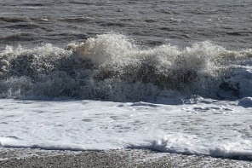
Your child will have up to 2 sessions a week in school playing TT Rockstar’s but if you could get your child to practise at home daily on the 2, 5 and 10s tables that would be great. More practise the better the retrieval of skills in their learning.

Art and DT
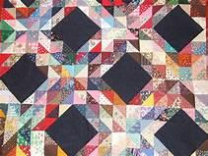
In ART we are drawing using the sea and water as our stimuli’s, we will be using a variety of materials to make marks and we will begin learn to understand that drawing is a response to a thought or an idea created by a point of inspiration. We will then go on to use paints to create effects.
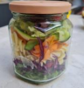
In DT we will be using the technique of applique to create a patchwork picture. We will use the over stitch to join two pieces of fabric together. After half term we learn what healthy means and what foods help us to stay healthy. We will be cutting and preparing salad to make a salad in a jar, quiche and tortilla wraps.

History
In History we will be learning all about schools in the past and comparing similarities and differences to schools today. If any grandparents would be willing to talk about their school experiences we would really appreciate it.

Geography
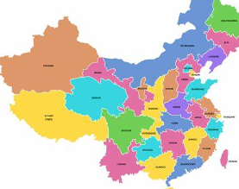
We will be learning about place knowledge and discovering China. We will be comparing life in New York to the UK and what it would be like to live in a city. Locating New York on a map and learning lots of interesting facts.

Computing
Basic skills using an I pad and keyboard and developing our understanding of the question ‘what should I do if an online friend wants to meet up?’

PE
Invasion games such as piggie in the middle and bounce ball will be introduced and then on to dance session in Autumn 2.

PE kits
PE kits should be in school every day and we ask that your child has trainers as they provide more support. Your child will need indoor and outdoor kit- blue shorts, white t shirt, jogging bottoms and jumper. They will be sent home every half term

Music
We are extremely lucky in Year 2 as we have a session of Samba in the Autumn term every Friday morning. We get to work as a band and perform.

PSHE
We will be learning all about ourselfs and relationships and valuing the differences in people.

RE
We will continue to develop our understanding of the bible and Christmas. We will have a harvest festival and a Christmas Carol service that will be held in Church. During our RE sessions we will visit a Mosque to explore other faiths and cultures and compare to Christianity.

Bookbags
Miss Woolley requests that your child only brings book bags to school, not backpacks as we have no space in the class for them. Your child must also have a coat and water bottle in school everyday.

Miss Woolley, Mrs Pope Jones look forward to working with you all this year and any queries or questions do not hesitate to ask!

