Year 6 Curriculum Newsletter
Autumn Term 2026
Welcome back to school and to Year 6! I am very looking forward to working with you all, as your child begins their final year at Christ Church Charnock Richard CE Primary School. You will receive a class newsletter at the beginning of every term where you will find out all about what Year 6 will be covering.
English We will start autumn term with different books to base our English lessons on these include: The Arrival by Shaun Tan, The Invention of Hugo Cabret by Brian Selznick, Windrush Child by Benjamin Zephaniah and Can We Save the Tiger?
Writing opportunities will include biographies, persuasive writing, own version of narratives and discussion texts.
Our reading lessons will be based on the classical novel: The Secret Garden by Frances Hodgson Burnett.
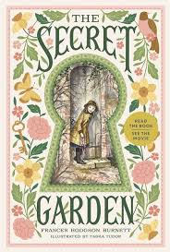.
How can you help? Encourage your child to read x3 sessions a week for 30 minutes both fiction and non-fiction. Promote the year 6 reading challenge Regularly, go onto spelling frame and into the year 3 and 4 areas to revisit spelling rules.
Maths In Maths we will be focusing on place value including decimals, mental and written addition, subtraction, division and multiplication calculations. We will be learning about fractions and percentages.
How can you help? Regularly, go onto TT Rock Stars and practise in garage and jamming areas. Also, complete sound checks every week. Every Monday there will be a multiplication challenge in school. This year I have new Rock star Pro badges – more to come about this!

History: What does the census tell us about our local area?
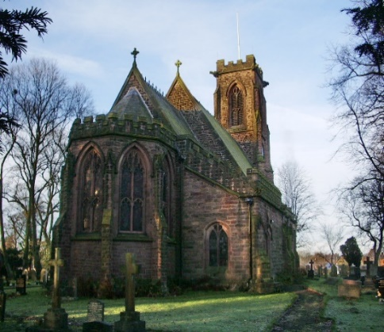
The children will study census to make inferences about people from the past and how their lives changed.
Computing
The children will be creating advanced power points and sharpen their keyboard skills.
ScienceThe children will cover the topic: All Living Things and Habitats. (Autumn 2)
Geography: An introductory study of Europe.
Art Drawing and painting.
DT Food and Nutrition and Mechanisms
AssessmentsIn Year 6 we have regular written assessements in the style of SATS papers – please do not use any past SATS papers to practise at home.
I will provide information about revision books at the SATs information night.
RE: The children will cover the units, Life as a journey and pilgrimage.
General Notices
PE kits – blue shorts, white t-shirt and trainers. Also, children need an outdoor kit (blue or black tracksuit).
Please make sure your child’s school uniform is clearly labelled with the child’s full name including their PE Kit.
Bikeability: Thursday 1st and Friday 2nd October (bikes can stay overnight in school on the Thursday)
Homework will continue in the style of the grid, with a variety of tasks. This needs to be completed by Monday 30th November.
This term, there will be a very important Year 6 meeting to provide information regarding SATS on Monday 5th October at 5:30pm. It is highly recommended that you attend. Please put the date in your diary.
As always, if you have any questions, or if you would like any further guidance in supporting your child, please don’t hesitate to come and speak to us!
Year 6 Team: Mrs Calvert & Miss Byrne

